BIOSECURITY PLAN – GRUNEY and RAMNA STACKS
Incorporating Prevention, Surveillance and Incursion Response
Plan completed by Holly Paget-Brown on 16/01/2025
Plan to be reassessed on 16/01/2026
Contents
1. INTRODUCTION 2
2. SITE DESCRIPTION 2
3. PATHWAYS and PREVENTION 2
VISITING STAFF/RESEARCHERS 3
SHIPWRECKS AND MARINE INCIDENTS (eg. CARGO SPILL) 3
SPECIALIST VESSEL (GRAZIER) 4
PRIVATE VESSELS 4
HELICOPTERS 4
SWIMMING AND FLOATING ON DEBRIS 5
INTENTIONAL RELEASE 5
4. SURVEILLANCE 5
HEDGEHOG, FERAL CAT, and MUSTELIDS 6
RODENTS 6
MAP OF SURVEILLANCE TOOLS 7
SURVEILLANCE TOOL LOCATIONS 7
5. INCURSION RESPONSE 13
LEGAL CHANGES 13
KEY INFORMATION FOR INCURSION RESPONSE 14
KEY CONTACTS 15
5.1 RODENT INCURSION RESPONSE 16
PROBABLE OR DEFINITE RAT INCURSION ACTIONS 16
POSSIBLE RAT INCURSION ACTIONS 17
EMERGENCY PLAN 18
5.2 MUSTELID INCURSION RESPONSE 19

1. INTRODUCTION
Purpose: The islands of Gruney and Ramna Stacks play host to a rich variety of wildlife including nationally and internationally important colonies of seabirds. Invasive non-native mammalian predators (hereafter ‘invasive predators’) pose a significant threat to sensitive ground-nesting bird species due to predation of eggs, chicks, and even adults. Biosecurity and this plan can prevent invasive predators reaching the island, help detect any that do arrive before they spread and establish, and provide clear instructions for what to do if there is an incursion.

2. SITE DESCRIPTION
Size of Island: 11.67ha | Distance from Neighbouring Land/Island: 1.6km North of Mainland and 6.5km West of Yell.
Ownership/Key Stakeholders: RSPB reserve for Ramna Stacks. Gruney is owned by XXX who the RSPB have a management plan with. There is a grazer, XXX, who sometimes grazes the island.
Island Access and Terrain: The island is difficult to access, and a landing must be made on uneven rock, typically on the SE point of the island. They are peat covered with coastal grassland. The stacks are mostly bare rock and inaccessible.
Invasive predators Present: None |  | Other mammals present:  Occasionally sheep | Risk Invasive predators: Mice, Rats, Stoats, Cats, Mink, Polecat, Hedgehogs
Native Species Present (especially those at risk from invasive predators or from eradication techniques): European storm petrel, Leach’s petrel, Guillemot, Shag, Kittiwake, and previously Puffins.

3. PATHWAYS and PREVENTION
Pathways: The ways in which invasive non-native mammalian invasive predators could reach the island. These are both human mediated and through natural means (such as swimming or storms).
Prevention: Everyone who lives on, or travels to, an island can use biosecurity measures to reduce the risk of invasive predators reaching the island. There are actions that can be taken to create barriers along pathways.
The details of pathways specific to Gruney and prevention methods that are currently in place are detailed below. Further best practice methods for prevention which could be implemented can be found here and general guidance to give to visitors can be found here.

VISITING STAFF/RESEARCHERS
Specifics: The warden team come to the island to carry out surveys and to do the biosecurity check. Some visits may include an overnight stay. | Risk Invasive predators: Brown Rat, Black Rat, Stoat, Ferret, Hedgehog, Feral Cat, Mouse | Risk Level: High
Details:  - Visits happen 1-2 times a year.  - Boat stored on Unst but occasionally stops on Yell.  - Launch site includes Collafirth and North Roe.  - Typically the RSPB, but also NatureScot and ecologists. | - Survey equipment and food are brought to the island.  - Camping happens less often but can occur
Prevention in place:  - Pack bags and equipment on the day of travel.  - Any food brought should be in rodent-proof containers and taken back with you.  - Waste should not be left on the island and should be taken back with you. | - Camping gear and other bulky equipment or tools should be checked before going to the island for predators or signs of them.  - Always use an open tender when landing on an island unless unavoidable.

SHIPWRECKS AND MARINE INCIDENTS (eg. CARGO SPILL)
Specifics: Shipwrecks on islands or large washed-up debris like a container. | Risk Invasive predators: Brown Rat, Black Rat, Mice, Stoat, Ferret, Hedgehog, Feral Cat, Mouse | Risk Level: Medium
Details:  - Shipwrecks are treated as incursions until proved otherwise. | - If a marine incident takes place within 1km from the island, increase surveillance along the adjacent coast, inform the incursion response hub to ensure readiness for rapid response if needed
Prevention in place:  - Incursion response readiness  - Pay attention to shipwrecks in the area. | - Surveillance in place, with extra on island.

SPECIALIST VESSEL (GRAZIER)
Specifics: Grazier boat | Risk Invasive predators: Brown Rat, Mice, Stoat, Ferret, Hedgehog, Feral Cat | Risk Level: Medium
Details:  - Grazier brings sheep to the island where predators might be hidden on board. | - Food and waste left on board the boat may attract predators.
Prevention in place:
- Grazier is aware of biosecurity

PRIVATE VESSELS
Specifics: Private boats that may visit the island or its proximity for the day or even stay overnight. | Risk Invasive predators: Brown Rat, Mice, Stoat, Ferret, Hedgehog, Feral Cat | Risk Level: Medium
Details:  - Transport of people who may bring bags ashore. If left unattended or open, predators may stowaway inside.  - People may bring food to the island or leave waste there.  - Some vessels may have higher risk cargo on board. | - As the boat goes near islands, predators may be able to swim to shore.  - If visitors stay overnight, camping gear may not have been used for some time and may have predators hidden in it.
Prevention in place:
- There is signage about biosecurity at some departure points for local vessels.
- Surveillance in place on island.

HELICOPTERS
Specifics: Helicopters may come to the island to service the lighthouse. | Risk Invasive predators: Brown Rat, Mice, Stoat, Ferret, Hedgehog, Feral Cat | Risk Level: Low
Details:  - Potential transport of high-risk materials, building materials and groceries. Predators may be attracted to these and easily hide away in them. | - Transport of people who may have bags and food. If left unattended or open, predators may stowaway inside.
Prevention in place:  - Northern Lighthouse Board are aware of biosecurity and have measures in place. May check surveillance when they visit the island. | - Have an incursion plan in place  - Surveillance in place on island.  - NLB have rodent control at their base.

SWIMMING AND FLOATING ON DEBRIS
Specifics: Many predators are strong swimmers and can travel several kilometres. They could swim from another close part of land or from a boat. They can also float on debris, especially in storms. | Risk Invasive predators: Brown Rat, Mice, Stoat, Ferret, Hedgehog, Feral Cat | Risk Level: Low due to distance from land.
Details:  - The island is far from the mainland so the chances of predators swimming is low. | - The chance of animals floating on debris is always possible.
Prevention in place:
- Upkeep of surveillance to catch predators should one rich the island in this way.

INTENTIONAL RELEASE
Specifics: People may bring predators to islands intentionally. This could be maliciously with knowledge of what it will do, or in ignorance where someone does not know they are a problem. | Risk Invasive predators: Brown Rat, Mice, Stoat, Ferret, Hedgehog, Feral Cat | Risk Level: Low
Details:  - There is no one specifically known who would have an interest in releasing a predator. | - The chances of someone bringing a predator to the island in this way are low
Prevention in place:
- Upkeep of surveillance to catch predators should one be released.

4. SURVEILLANCE
Preventing invasive predators from reaching Gruney using the methods above is ideal; however, if an animal did reach the island, it is very important that it be detected before a population has time to establish. Eradicating a population is difficult, expensive, and may not be successful, so prevention is better than cure. Carrying out simple routine surveillance on-island allows us to quickly detect any invasive predators that evade the barriers in place above. If an animal or signs of an animal are found, then an incursion response is triggered.

As access to the island is difficult it is recommended that replacement wax, additional surveillance tools such as cameras, and some bait are brought in case suspicious sign is found on the visit.
Surveillance present on the island is listed below.

Further advice for a wider range of species and more details can be found here along with details about each species and instructions for making wax blocks

Surveillance data can be entered on the Survey123 app which can be downloaded onto your phone.
- Open the app and press the ‘Continue without signing in’ option.
- In the search bar at the top of the ‘My Survey123’ opening screen, click the QR code icon.
- Scan the QR code:

- The app will download the survey and open it automatically for you to use and will always be available.
- Enter your data following the instructions in the app.
- New stations can be added into the app by emailing GPS data to biosecurityforlife@rspb.org.uk but do note that new stations will not appear in the app until it is next updated.

HEDGEHOG, FERAL CAT, and MUSTELIDS
- Visual searches for signs such as droppings, footprints, feeding sign, carcasses (e.g. rabbits) done during other biosecurity checks and opportunistically.
- Camera traps, ad hoc or when suspicious sign is found.

RODENTS
- Surveillance stations with non-toxic flavoured wax blocks.
- Checked once a year or more when there is budget for boats. (do note a minimum of 4 visits is best practice).
- Wax to be replaced every visit due to infrequency of checks.
- Visual searches for sign such as droppings, footprints, feeding sign, carcasses, runs, burrows done during other biosecurity checks and opportunistically.
- Camera traps, ad hoc if multiple visits in a year are occurring, or when suspicious sign is found.

MAP OF SURVEILLANCE TOOLS
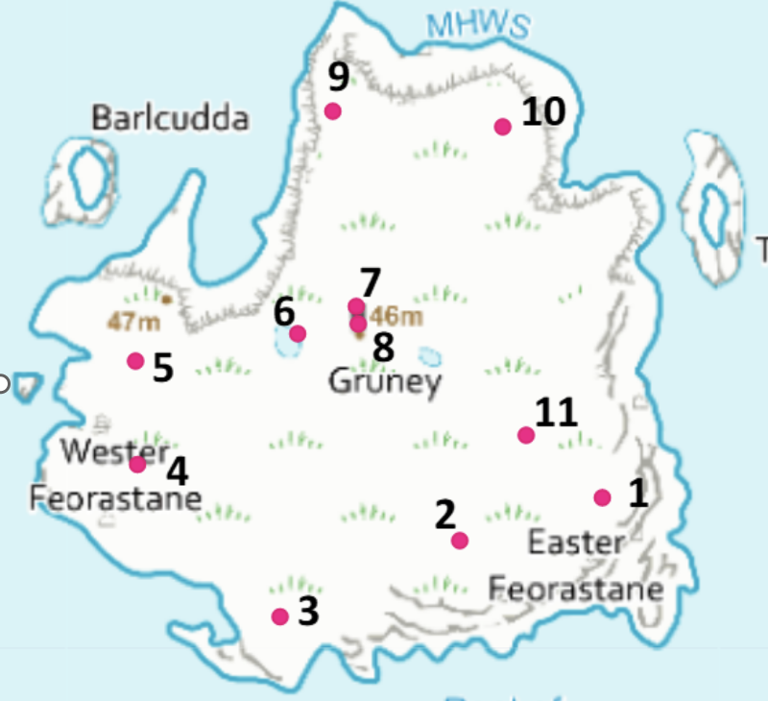

SURVEILLANCE TOOL LOCATIONS
No. | Long | Lat | Photo
GRU001 | 60.65193 | -1.30385 | 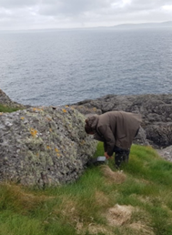
GRU002 | 60.65174 | -1.30519 | 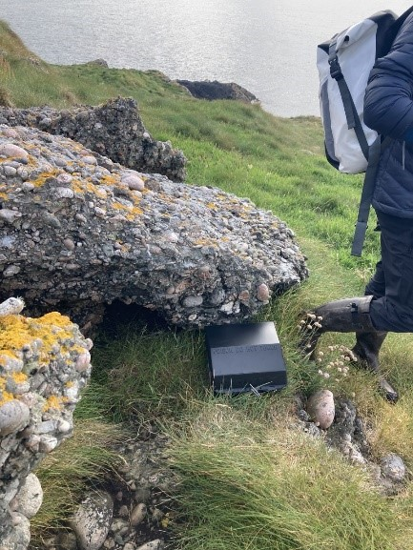
GRU003 | 60.65139 | -1.3052 | 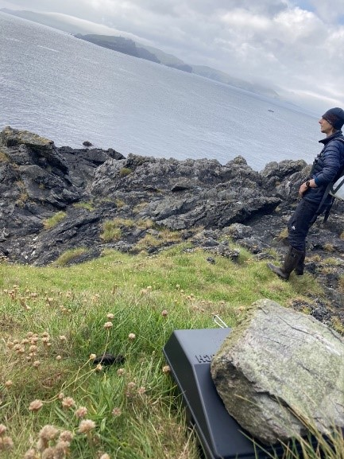
GRU004 | 60.65211 | -1.30365 | 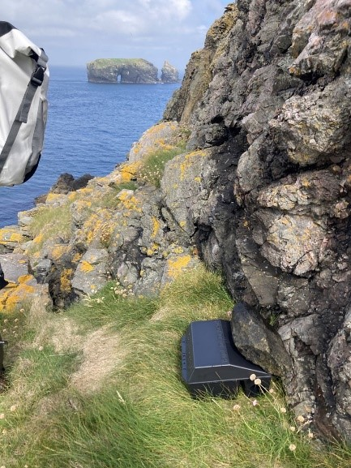
GRU005 | 60.65259 | -1.30309 | 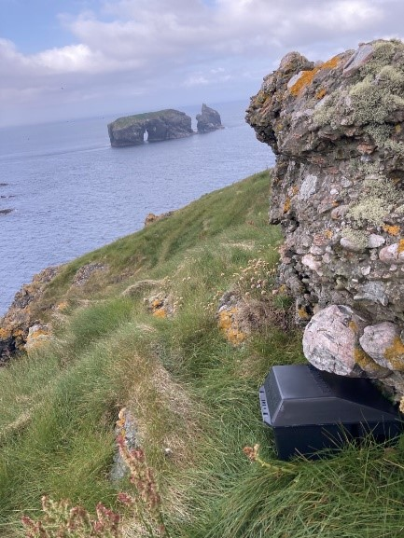
GRU006 | 60.65271 | -1.30307 | 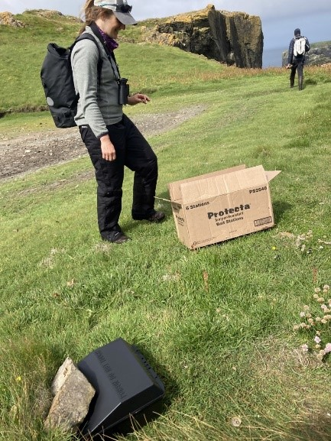
GRU007 | 60.65283 | -1.3033 | 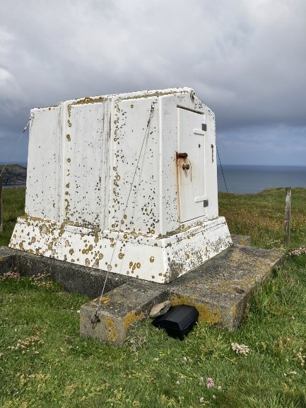
GRU008 | 60.65275 | -1.30168 | 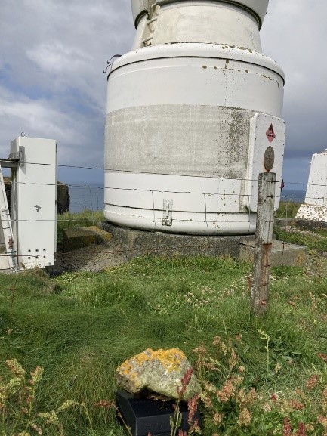
GRU009 | 60.65375 | -1.30149 | 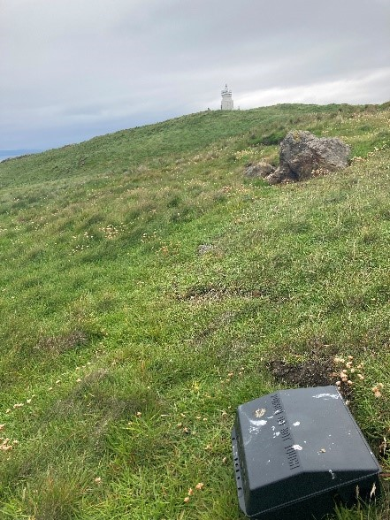
GRU010 | 60.65367 | -1.30385 | 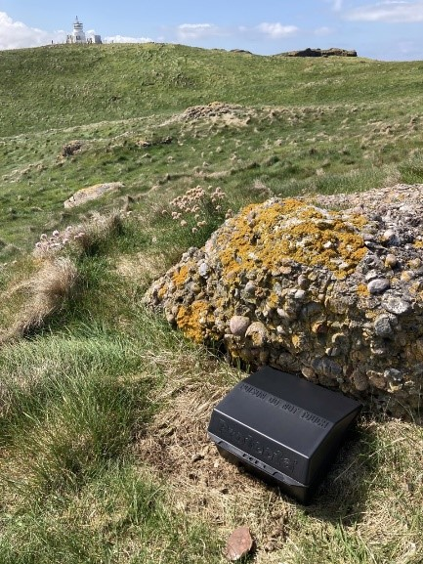
GRU011 | 60.65223 | -1.30519 | 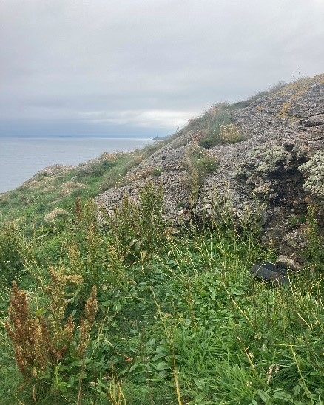

5. INCURSION RESPONSE
If an invasive predator is found on Gruney or signs of one are spotted, then it is important to respond quickly to minimise the risks of a population establishing on the island. The faster the response the easier it will be to remove any animals and prevent damage to native species.
Any suspected or confirmed incursion should be responded to immediately with the aim of initiating the full incursion response plan within 48 hours, preferably less, to prevent the predator roaming more widely.
There are best practice methods for incursion responses but sometimes these are not always possible or practical. In the event of an incursion where you are unsure of the best course of action, contact the biosecurity officer or biosecurityforlife@rspb.org.uk and they can provide advice on how to best respond in each situation.
Make sure you have risk assessments for activities surround incursion responses (boat use, camping on islands etc) ready in advance.

LEGAL CHANGES
As of January 1st 2025 second generation anticoagulant rodenticide (SGAR) are now illegal to use in outside areas. To still use them for incursions an agreement has been reached with HSE.
The agreed approach will be the use of Critical Situation Permits (CSP), and HSE have worked to produce a procedure that will allow these permits to be issued within 24-hours so that incursion responses can be launched in line with best practice as detailed in the UK Rodent Eradication Best Practice Toolkit.
This process is in place for brown rat Rattus norvegicus only. Further discussion will be held to explore possible solutions for black rat Rattus rattus and house mouse Mus musculus and no SGAR products are currently authorised for outdoor open area use for these species.
The procedure in brief is as follows:
Contact HSE
- In business hours (Monday to Friday): Send an email to biocidesenquiries@hse.gov.uk and copy BiocidesApplications@hse.gov.uk in.
- Out of business hours (Friday evening to Sunday, and bank and public holidays): Contact HSE’s duty officer on 0151 922 9235.
Information Required for HSE
1. The organisation asking for the permit.
2. A named individual and contact details (email address and telephone numbers) and the postal address for the organisation.
3. The island where there has been an incursion.
4. The two products that you will use: one containing bromadiolone and the other one difenacoum.
5. The amount of each product that you will use for the whole incursion including weekly full grid replacements (two blocks per tunnel). For Gruney this will be 13kg Contrac Blox for bromadiolone, and 10kg Roban Octablox or Ratimor Difenacoum Blocks for difenacoum.
If you would like the full HSE procedure document, please contact your Biosecurity Officer.

KEY INFORMATION FOR INCURSION RESPONSE
Who is responsible for leading incursion responses on the island: XXX
Who is responsible if the above is away: XXX
Incursion hub Location and access: RSPB Sumburgh Head, Shetland, ZE3 9GL. Map pin here. Go to the RSPB office to get the keys or contact those listed below. Note you will need the key for the rodenticide cabinet also. This is currently held by the warden and biosecurity officer.
Transport from hub to boat/island: Work van.
Boat to use in incursions: XXX boat, contact number XXX, operates at XXX time of year, costs roughly XXX
Second boat option: XXX
Permissions Required: NatureScot, landowner.
When were these permissions granted if done in advance and were there any conditions?
Best practice alterations: The island is hard to access reliably due to weather so having people camp for even a short period would be a challenge, and frequent repeat visits may be difficult. As such, if bait/traps are deployed, when they are checked may not be within best practice guidelines.
Stakeholders to inform and keep updated: NatureScot, landowner, grazier.

KEY CONTACTS
Name | Role and Incursion Role | Email | Phone | Rodenticide Certified?
 | RSPB Senior Site Manager  Incursion Lead |  |  | Yes
 | Biosecurity Officer  Advice and support |  |  | Yes
 | RSPB Warden |  |  | Yes
 | RSPB Assistant Warden |  |  | No
 | NatureScot Staff  Permission for rodenticide/trapping |  |  | No
 | Boat owner |  |  | No
 | Landowner |  |  | No
 | Grazier |  |  | No

5.1 RODENT INCURSION RESPONSE
Note that anyone buying or handling rodenticide in packs sold for professional use will need to do a short online course in safe rodenticide use. A list of approved courses is available at https://www.thinkwildlife.org/training-certification/
As SGARs can no longer be used for mice or black rats, if you suspect you have one on your island, please contact your Biosecurity Officer to determine the best course of action with the tools we do have.
If you need to interview someone about a potential rodent sighting, use the interview form here.

PROBABLE OR DEFINITE RAT INCURSION ACTIONS
Probable signs of rats include clear toothmarks on monitoring tools or other items, droppings, burrows, footprints, predated birds or other clear feeding sign, inconclusive photographs, or partial or brief sightings made by people familiar with rodents.
Definite signs include rat carcasses, clear photographs and clear sightings made by people with experience of rats or mice, DNA evidence (eg. From droppings). Shipwrecks will be treated as definite incursions.
Full advice can be found here.

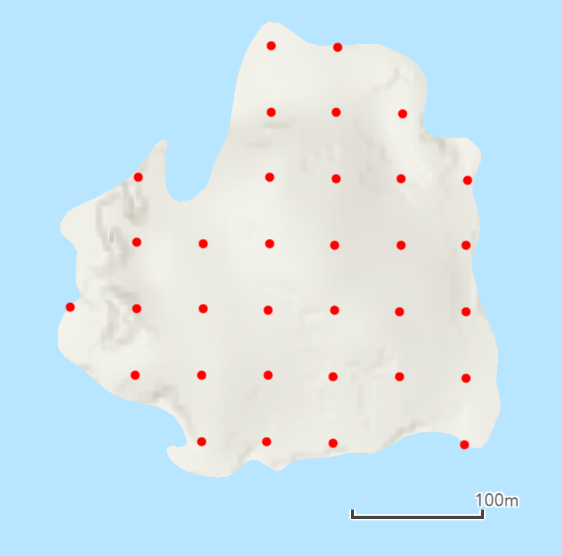
In brief, you will need to do the following:
- Deploy bait stations in a grid 500m in all directions from location of sighting with stations every 50m.
- As Gruney is small, no matter where the rat is suspected to have been, the whole island will need to be covered.
-The map (right) shows how the stations could be placed on Gruney.
- You will need 30-35 bait stations. And can put additional bait in existing surveillance stations.

- Stations should contain 3x 20g blocks of second-generation anticoagulant rodenticide.

- Increase surveillance in areas likely to be used by rats (cameras, tracking tunnels)
- The stations should be checked and bait replaced where required every 2-3 days for first week, twice weekly for the next two weeks, and weekly for the next four weeks.

- As the island is hard to access reliably due to weather, having people camp for even a short period would be a challenge, and frequent repeat visits may be difficult. As such, when they are checked may not be within best practice guidelines but should be as close to them as is feasible and safe.

- When checked, at each station note any signs of rodents or non-target species taking the bait and the number of blocks added/replaced.

- Check for sign (droppings, holes, runs) in areas identified above when deploying/checking surveillance equipment.

- If no further sign or bait take is found after 7 weeks you can end the response.

- Record all signs found and actions taken throughout the response. Review the biosecurity plan and incursion response in consultation with your Biosecurity Officer.

POSSIBLE RAT INCURSION ACTIONS
Possible signs include finding one or more dead birds or other animals showing possible signs of predation, unclear or degraded footprints, burrows or droppings, sightings made by people unfamiliar with rodents or unclear sightings made by people who are familiar with rodents, bulky high-risk cargoes being brought to the island, such as building materials, or storm debris washing ashore on the island.
- Deploy increased surveillance in grid 250m in all directions from location of sighting with monitoring stations every 50m (wax blocks, camera traps, and tracking tunnels). Check stations every 2-3 days for the first 2 weeks and then weekly for a month.

- As the island is hard to access reliably due to weather, having people camp for even a short period would be a challenge, and frequent repeat visits may be difficult. As such, when they are checked may not be within best practice guidelines but should be as close to them as is feasible and safe.

- Increase surveillance in areas likely to be utilised by invading animals. Eg. fresh water sources, buildings, nesting seabirds.

- Check for sign in areas identified above when deploying/checking surveillance equipment.

- If no further sign is found return to normal levels of surveillance after 1 month.

- Record all signs found and actions taken throughout the response. Review the biosecurity plan and incursion response in consultation with your Biosecurity Officer.

EMERGENCY PLAN
1. Determine if it is a possible, probable or definite incursion.
- Carry out an interview using this form if the animal was seen by a member of the public.
- Decide what response method you are going to use.
2. Work out how many trips to the island you have the budget to do. This may impact what incursion/surveillance methods you use.
- Also consider the time of year, weather conditions, and bird breeding status.
3. Contact relevant key people:  - Incursion Leader  - Island owner/community  - Site manager, wardens, rangers  - Biosecurity for Scotland team  - Incursion Hub coordinator  - Volunteers  - Boat operator | Purpose of contact:  - To lead and organise the incursion response  - To keep informed and grant access  - To keep informed, help, and grant access  - To provide advice, support, and to organise dog check.  - To ensure access to the hub is possible transport to the island ASAP.  - To help in the incursion response set up and checks  - To organise transport
4. Organise collection of and collect required incursion equipment.
5. Ensure your boat operator is available to take you to the island and has the space to accommodate the incursion equipment (50 bait tunnels take up roughly 1m squared and are reasonably heavy, only 8-10 can be carried comfortably in a bag at a time).
6. Once a date/time for the island visit has been decided contact staff who may be able to help, volunteers, and volunteer leaders. The Biosecurity for Scotland team may be able to help with this.
- You want to find as many people as you can to come and help with the initial set up.
- Make sure they are rodenticide certified if they will be handling rodenticide.
- Ensure you bring a minimum of two people who have first aid training.
- Volunteers should be registered with the RSPB.
7. Contact the Biosecurity for Scotland Team to see if a Conservation Detection Dog handler is available to come to the island to help at short notice if it is a brown rat incursion.
8. Fill in any relevant risk assessments for the visit such as for camping on remote islands if staying overnight, boat safety etc.
9. Go to the island and carry out the incursion response. Keep stakeholders informed and updated as required.
10. Review the biosecurity plan and prevention measures in place after the incursion is complete.

5.2 MUSTELID INCURSION RESPONSE
For advice or help writing a trapping plan in the event of a mustelid incursion please contact your biosecurity officer.
Detailed information on all aspects of mustelid (stoats, mink, ferrets/polecats) incursion response are on the Biosecurity for LIFE website here. It is important that you read it to know what to expect.
It covers:
- The law
- Determining the species
- Determining the level of response
- Trap type, setting, and placement
- Checking traps
- Ending the response
- Bycatch and mitigation
- Trap servicing guidance
- Carcass collection and disposal
- Data recording
- Plan checklist for first visit
- DOC trap risk assessment

